Normal Distribution (Gaussian Distribution) and Standard Normal Distribution

# Normal Distribution or Gaussian Distribution

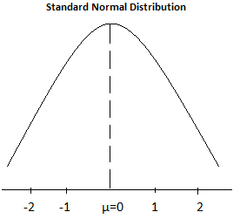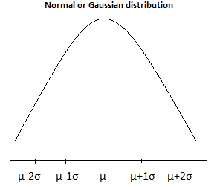

In a Normal distribution, % of data is distributed as follows:

|  |  |  |
| --- | --- | --- |
| Within 1 standard deviation | M-1SD to M+1SD | 68% |
| Within 2 standard deviation | M-2SD to M+2SD | 95% |
| Within 3 standard deviation | Remaining | 99.7% |

# Converting Normal distribution to Standard normal distribution (SND)

In a SND, µ = 0 and σ = 1. Therefore, values get converted as;

µ+1σ becomes 1; µ+2σ becomes 2; µ-1σ = -1; and µ-2σ = -2

Using Z-score we can scale values to SND.

$$Zscore= \frac{Xi-µ}{}$$

Where,

Xi = Point on the x-axis

µ = Mean

σ = Standard deviation

# (Standardization or Z-score Normalization)

Let’s take an example

{ 1, 2, 3, 4, 5 }

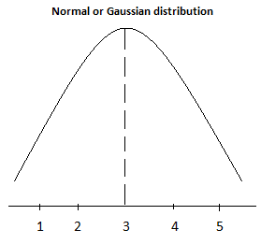

Here Mean (µ) = 3 and standard deviation (σ) = 1

Now when you apply Z-score and transform the values to SND,

For Xi = 1, Xi’ = (1-3)/1 = -2 **Xi’** is the normalized value.

Xi = 2, Xi’ = -1

Xi = 3, Xi’ = 0

Xi = 4, Xi’ = 1

Xi = 5, Xi’ = 2

So we get,

*Some other ways of scaling data are, Mean Normalization, Min-Max Normalization, Unit-Length scaling

Let’s see a practical example.

We have a population of students with scores as,

55, 65, 75, 85, 95

Problem statement – What is the probability that the student will score more than 60%

Form the data, we can calculate the Mean (µ) and Standard Deviation (σ) and plot the graph as below:

Let’s assume that we have a normal distribution with this data

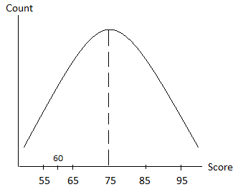

When we convert this to a SND, we should be getting

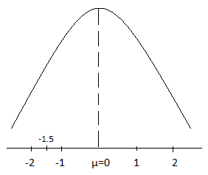

The value 60 now gets converted to -1.5 (assume, this is not exact). We have to find the % of population which falls in the marked region.

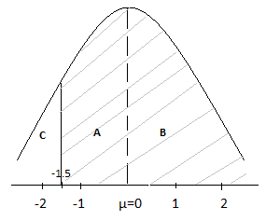

We can determine the % of population in **C**, by using the z-score table.

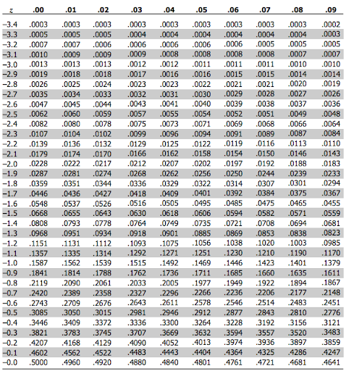

The z-score value for -1.5 is 0.0668 which is ~ 6.68%

So **C** = 6.68%

**B =** 50% since it is normally distributed.

Let’ assume **A** is x

Now we have

x + 50 + 6.68 = 100

x = 100 – 56.68 = 43.32%

Therefore A+B = 50 + 43.32 = **93.32%**

**Therefore, the probability that a student will score more than 60 is 93.32%**